***____________________________CRUD_JAVA__________________________***

**Nama : Muhamad Wahyu Saputra**

**Kelas : XII RPL B**

**Absen : 34**

**Modul 10**

1. Buat database terlebih dahulu  
   disini saya membuat db dgn nama karyawan  
   A screenshot of a computer

   Description automatically generated

Kemudian buatlah 1 table dengan nama tbl gaji dan buat 6 kolom

Selanjutnya isi field dan valuenya dengan gambar dibawah ini,ketika sudah selesai mengisinya kemudain klik kirim

1. Buat Project di netbeans  
   Buat nama project 🡪 app_database lalu klik finish  
   A screenshot of a computer

   Description automatically generated

buat Package dengan nama Koneksi & Karyawan  
1.isikan package karyawan dengn file Jframe form  
 pilih Jtable dan drag&drop ke papan jFrame

kemudian ubah variabel jtable dengan tblGaji

Source code

2.isikan package koneksi dgn file java class db_koneksi  
Source code Db_Koneksi.java

Kemudian silahkan di run  
 tampilan ketika berhasil

Tampilan akhir

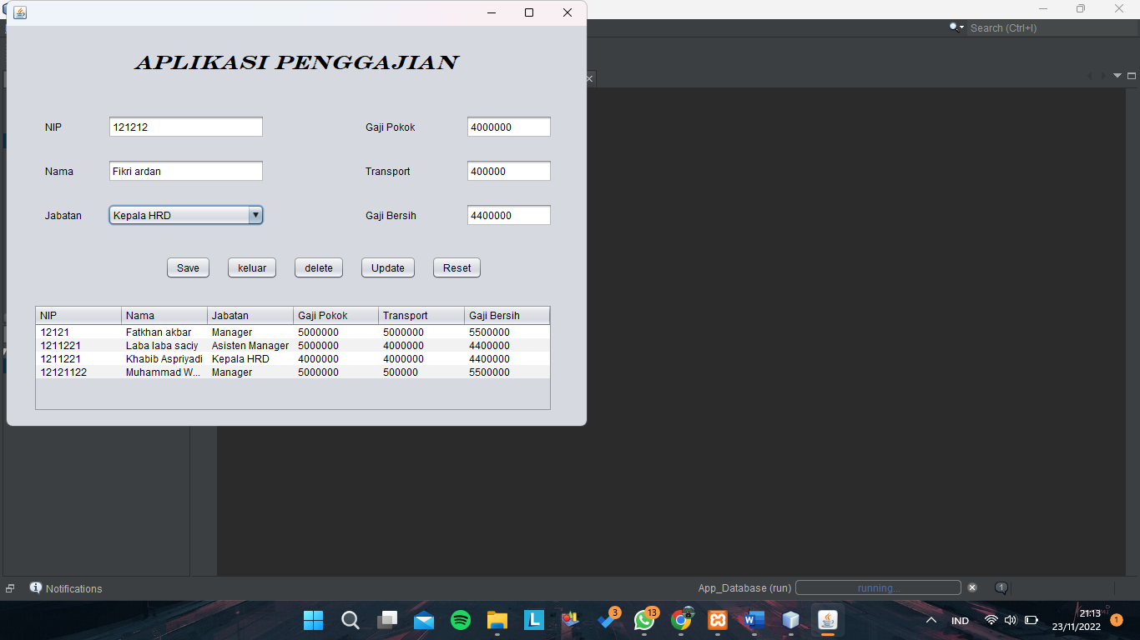

PRAKTIKUM  
HASIL

